Claude Opus 4.8 Released: Core Upgrades, Benchmarks, and Migration Guide
Just 41 days after the release of Claude Opus 4.7, Anthropic launched another flagship iteration on May 28, 2026 — Claude Opus 4.8. This update comes without a price increase, yet introduces substantial improvements in coding honesty, agent workflows, speed control, and more. Is this a genuine upgrade or simply another version-number refresh? This article breaks it down from three perspectives: core capabilities, benchmark performance, and real-world adoption scenarios.
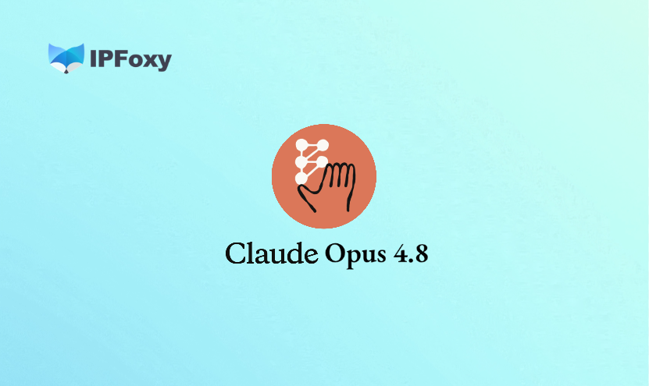


I. Claude Opus 4.8 Core Upgrades Overview
Claude Opus 4.8 is positioned as a “modest but tangible improvement.” Anthropic explicitly stated that this release focuses on agent task capabilities while introducing three major new features alongside multiple model upgrades.

1.Detailed Upgrade Improvements
- Agentic Coding
The SWE-bench Pro score jumped from 64.3% in Opus 4.7 to 69.2%, while SWE-bench Verified increased from 87.6% to 88.6%. These are currently the highest scores among publicly tested models, directly reflecting issue-solving ability in real open-source repositories. For engineering teams, this is more than just a benchmark number — it means Claude Opus 4.8 achieves significantly higher success rates when handling actual bug-fixing tasks.
- Terminal Coding
Claude Opus 4.8 scored 74.6% on Terminal-Bench 2.1, a notable improvement over Opus 4.7’s 66.1%, although GPT-5.5 still leads with 78.2%. Anthropic remained transparent about this in its official notes: Claude Opus 4.8 is not yet the top performer for pure terminal/CLI workflows, but it has surpassed Gemini 3.1 Pro at 70.3%.
- Reasoning and Mathematics
On Humanity’s Last Exam (HLE), the model scored 49.8% without tools and 57.9% with tool assistance, ranking first among the four compared models. GPQA Diamond reached 93.6%, while the GDPval-AA real-world work quality leaderboard placed it at an Elo score of 1890, outperforming GPT-5.5 by 121 points.
- Code Honesty
This is the improvement Anthropic emphasized the most. Compared with Opus 4.7, the new model is four times less likely to silently ignore code defects. It actively marks uncertainty in its own outputs rather than masking mistakes with overconfidence. Early testers reported that the model says “I’m not sure” more quickly and shows less false confidence in uncertain situations.

2.New Features Explained
- Fast Mode
Fast Mode can generate tokens at approximately 2.5× standard speed, reaching around 62 tokens per second in real-world testing. The most important change is pricing: Fast Mode for Opus 4.8 costs $10/$50 per million input/output tokens, a threefold reduction from Opus 4.7’s $30/$150 pricing. It shares the same model weights as standard mode, meaning quality remains unchanged. This mode is especially suitable for latency-sensitive applications such as real-time code completion and customer support systems.
- Dynamic Workflows
Currently available as a Research Preview, this feature is limited to Claude Code Enterprise, Team, and Max plans. The workflow works by letting Claude first build an overall execution plan, then launch hundreds of parallel sub-agents to complete tasks independently before validating and merging the final results.
Anthropic demonstrated this with large-scale codebase migration tasks involving hundreds of thousands of lines of code, where AI handled the process from start to merge while existing test suites acted as validation criteria. In practice, Dynamic Workflows gives Claude Opus 4.8 the ability to process tasks beyond a single context window for the first time.
- Effort Control
All claude.ai subscription users can now access an effort-level slider inside the chat interface. The available levels include standard, high (default), xhigh, and max.
Higher settings enable deeper reasoning but consume more rate-limit quota, while lower settings provide faster responses with lower quota usage. Developers can also update system prompts mid-task through the Messages API without breaking prompt caching or introducing additional user turns, allowing more flexible agent instruction orchestration.


II. Claude Opus 4.7 vs 4.8 Full Comparison
Category | Claude Opus 4.7 | Claude Opus 4.8
Standard Pricing | $5/$25 per million tokens | Unchanged at $5/$25
Fast Mode Pricing | $30/$150 | $10/$50 (3× cheaper)
Fast Mode Speed | — | 2.5× standard speed
SWE-bench Verified | 87.6% | 88.6%
SWE-bench Pro | 64.3% | 69.2%
Terminal-Bench 2.1 | 66.1% | 74.6%
GPQA Diamond | 94.2% | 93.6% (slightly lower)
GDPval-AA Elo | ~1753 | 1890
OSWorld-Verified | 82.3% | 83.4%
Code Honesty | Baseline | 4× fewer silent misses
Dynamic Workflows | Not supported | Supported (Enterprise/Team/Max)
Effort Control | xhigh only | Full slider for all plans
Output Token Efficiency | Baseline | ~35% reduction
Context Window | 1M input / 128K output | 1M input / 128K output

III. Is Claude Opus 4.8 Worth Using?

1.From a Use-Case Perspective: Is Migration Worth It?
- Large Codebase Maintenance
A SWE-bench Pro score of 69.2% reflects real repository issue-fixing capability. Teams managing multiple cross-file bugs every week may significantly reduce manual intervention by combining Claude Opus 4.8 with Dynamic Workflows.
- Code Review Requiring Reliability
Improved honesty is one of the most practical upgrades in this release. For teams using AI-assisted code review, a model that actively says “there may be an issue here” is far more valuable than one that sounds confident while being wrong.
- Real-Time User Interaction Products
The 3× price reduction in Fast Mode means the same budget can support many more real-time responses. This directly changes the cost structure for developers building AI copilots or customer service applications.
- Large-Scale Migration Tasks
Dynamic Workflows was designed specifically for tasks too large for a single context window. Codebase refactoring, large document processing, and multi-step data pipelines are all potential beneficiaries.

2.From a User Perspective: Is Upgrading Worth It?
- Individual Developers and Independent Creators
Standard pricing remains unchanged, the effort slider is available to all users, and Fast Mode pricing has dropped significantly. Since the upgrade cost is effectively zero, switching is strongly recommended.
- Small and Mid-Sized Engineering Teams
The biggest advantages are the SWE-bench Pro improvement and enhanced honesty. Migration is simple — changing the API model ID to claude-opus-4-8 only requires one line of code.
- Large Enterprises and Platform Developers
Dynamic Workflows is currently limited to Enterprise, Team, and Max plans and still remains in Research Preview. It is recommended to conduct gradual testing on non-critical workloads first to validate token consumption and stability before wider deployment.
- Pure Terminal Automation Workflows
GPT-5.5 still leads Terminal-Bench 2.1 by 3.6 percentage points. If your core workflow relies heavily on pure CLI operations, real-world A/B testing is recommended before making a final decision.

IV. Claude Opus 4.8 Usage Recommendations

1.Pay Attention to Token Budgets
The default effort level has shifted from standard in Opus 4.7 to high in Opus 4.8, meaning each conversation now consumes more tokens by default. For low-complexity tasks such as simple Q&A or draft generation, lowering the effort level can reduce quota usage and improve response speed.
Parallel sub-agent workflows can also dramatically increase token consumption. Before launching large-scale tasks, run smaller tests first to verify expected behavior and avoid wasting large amounts of quota on unexpected outputs.

2.Improved Honesty Does Not Eliminate Errors
Opus 4.8 is better at marking uncertainty, but mistakes still happen. The key difference is that errors are less likely to be silently ignored. Human review should still remain part of critical code paths, with AI self-reporting treated as an additional safety layer rather than a replacement for QA processes.

3.How to Improve Code Stability
Set the effort level to xhigh or max so the model spends more time reasoning before responding. Break large projects into smaller tasks instead of asking the model to process thousands of lines at once. After code generation, ask follow-up questions such as “Are there any potential issues in this code?” — Opus 4.8 is now much more likely to answer seriously rather than dismissively.

4.How to Reduce Account Risk Controls
Avoid sending large volumes of repetitive or highly similar requests within short periods of time. Claude Code users should note that Dynamic Workflows and xhigh mode can quickly consume rate limits, so request frequency should be controlled carefully.
Frequent switching between network environments should also be avoided, especially repeated logins from IPs across multiple regions using the same account. A common solution is configuring a stable dedicated static residential proxy from professional proxy providers such as IPFoxy Proxies. Its dedicated static residential IPs are sourced from real residential networks and can help heavy Claude users maintain stable environments while reducing account risk-control issues and potential suspensions.
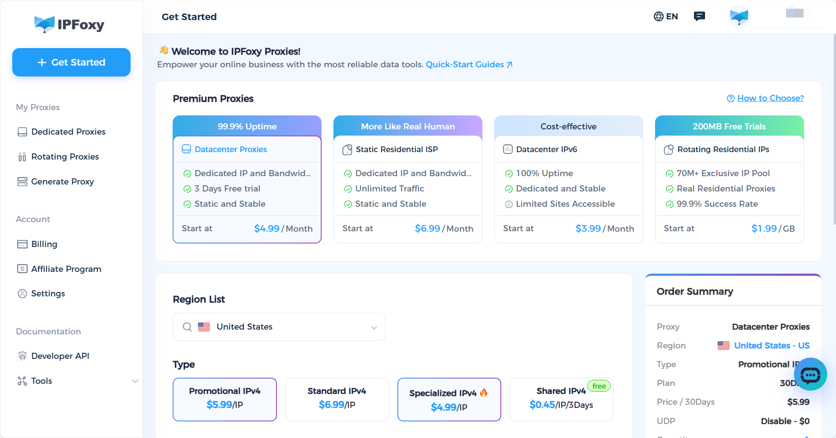

V. FAQ
Q: Is Dynamic Workflows available to all users?
Currently, it is in the Research Preview stage and only available for Claude Code Enterprise, Team, and Max plans. Free and Pro individual plans do not support it yet.
Q: Which is stronger, Claude Opus 4.8 or GPT-5.5?
Each model has its own strengths. Opus 4.8 leads in agentic coding (SWE-bench Pro 69.2%), computer interaction tasks (OSWorld 83.4%), and overall real-world work quality (GDPval-AA Elo 1890). GPT-5.5 still maintains an advantage in pure terminal coding workflows (Terminal-Bench 78.2% vs 74.6%) while offering lower output token costs.
Q: When will Anthropic’s Mythos model be released?
Anthropic has confirmed that the Mythos-class model will become available to all users “within weeks.” At the moment, access remains limited to selected enterprise partners.

VI. Conclusion
Claude Opus 4.8 is a meaningful iteration rather than a superficial version-number update. Its core value can be summarized in three areas: more honest code feedback with four times fewer silent misses, stronger agentic coding performance with a SWE-bench Pro score of 69.2%, and more flexible usage controls through cheaper Fast Mode pricing and the new effort-level slider.
Anthropic has also confirmed that the more powerful Mythos-class model will become available to all users within the coming weeks. In many ways, Claude Opus 4.8 feels like an acceleration step within a larger upgrade cycle — already worthwhile on its own, while even stronger models are still ahead.

